

Agile Scrum

System Documentation

Policy Manual

Published By

Software Research Group 7th Generation

Polytechnic University of the Philippines

Quezon City Branch

Don Fabian St, Commonwealth Ave. Quezon City

Inquiries should be addressed to:

Polytechnic University of the Philippines

Quezon City Branch

Information Communications and Technology Center Office

Software Research Group

Don Fabian St, Commonwealth Ave,

Quezon City, Philippines

Website: srg.pupqc.net

Editors:

**Cristian O. Balatbat**

Typeset/Layout:

**Cristian O. Balatbat**

**Lowell Dave E. Agnir**

**Foreword**

This manual is produced by the PUPQC Software Research Group 7th Generation for System Documentation, in terms of software project development applying the principles of agile scrum methodology, in its eﬀort to unify the standards for creating systems documentation as course requirement for the Bachelor of Science in Information Technology. This contains the set of guidelines on the organization and style of the documentation.

The Software Research Group trusts that this manual will serve its purpose of standardizing the system documentation with the application of agile scrum methodology produced by the Information Technology students of PUPQC and will contribute to the Institution’s thriving system development and research principles.

MA. MICHAELA ALEJANDRIA

Project Manager,

SRG 7th Generation

**Table of Contents**

|  |  |
| --- | --- |
| **Title Page**  **Manual Identification Page**  **Foreword**  **Introduction**  **Parts of the Documentation**  **Documentation Preparation**  Paper and Printing Specification  Font Specifications  Spacing  Margins  Headers and Footers  Page Numbering  Table Specifications  Figure Specifications | **1**  **2**  **3**  **4**  **5**  **6**  8  8  8  8  9  9  10  12 |

1. **Introduction**

The Polytechnic University of the Philippines, Quezon City Branch expects the BSIT students to produce high-quality software and other systems that manifest their ability as an IT practitioner, but also must practice good and high-quality documentation skills that will serve as the backbone of their systems and project development planning, organization, management, and completion.

In creating a system documentation, the BSIT students shall comply with the standards set by PUPQC ICTC Office. They are responsible for consulting the PUPQC ICTC office regarding the requirements for creating their system documentations and are discouraged from just following the format of another system documentations.

The PUPQC ICTC management approves the ﬁnal system documentation and reserves the right to reject documents that departs from the guidelines speciﬁed in this manual. Students are advised to read this manual carefully, paying close attention to the details of the documentation, including the samples in the Appendices. In addition to structural formatting, they are also responsible for assuring that their manuscript follows conventional rules of grammar, punctuation, and spelling. The PUPQC ICTC management encourages the students that they seek assistance from a knowledgeable person to help them improve their work.

1. **Parts of the Documentation**

The system documentation with the application of agile scrum methodology shall contain the following:

|  |
| --- |
| **Title Page**  **Preface**  **Table of Contents**  **List of Figures**  **List of Tables**   1. **Project Background**    1. Project Description       1. Vision and Objectives       2. Project Estimation          1. Size          2. Complexity       3. Scope and Limitation       4. Project Organization       5. Project Resources          1. Human and Financial          2. Communication and Technology       6. Development Priorities       7. Success Criteria       8. Project Road Map    2. Project Plan 2. **Product Backlog**   2.1 Product Backlog for User Stories  2.2 Product Backlog for Information Security  2.3 Product Backlog for Standards  2.3.1 For User Interface and Messages  2.3.2 For Database  2.4 Product Backlog for Integration  2.5 Product Backlog for Analytics     1. **Sprint Backlog**   3.1 Sprint Backlog Table  3.1.1 User Stories  3.1.2 Information Security  3.1.3 Standards  3.1.4 Integration  3.1.5 Analytics  3.2 Sprint Backlog Table  3.2.1 User Stories  3.2.2 Information Security  3.2.3 Standards  3.2.4 Integration  3.2.5 Analytics   1. **System Application Overview**   4.1 General Overview  4.1.1 General Description  4.1.2 User Access and Control  4.2 System Architecture  4.3 System Operations Manual  4.3.1 Getting Started  4.3.2 System Navigation and Pages   1. **Project Outcome**   5.1 Project Plan Evaluation  5.2 Conclusion  5.3 Recommendation  **Appendices**   1. Database Dictionary 2. Test Scripts 3. Requirements Traceability Matrix 4. System Screenshots 5. Attachments |

1. **Documentation Preparation**

In the preparation of the documentation, care shall be taken to ensure that the following speciﬁcations are followed:

**Paper and Printing Specification**

Print the ﬁnal copy in a letter-sized bond-paper (8.5 x 11 inches).

**Font Specifications**

For the Whole Document, use Arial Font style.

For Chapter titles, use 14-pt as Font size, Boldface.

For headings, use 12-pt as Font size, Boldface.

For sub-headings, paragraphs, lists, table and figure headings and content, use 11-pt as Font size.

**Spacing**

Use 1.5 spacing all throughout the content; Headings must be single-spaced from the top margin or from the last paragraph/table/figure.

For paragraphs, figures, and tables, add space after paragraph after following the heading/sub-headings.

The headings for Preface, Table of Contents, List of Figures and Tables must be centered-aligned and boldface, must also be single-spaced from the top margin. These pages must be started always in a new page.

**Margins**

Leave 1.5 inches for the left margin to allow for binding and trimming and 1 inch for the top, bottom, and right margins.

**Headers and Footers**

Add a line that will serve as design for top and bottom margins, specifications will be a weight of 4-pt, and color will be blue.

Add text, left-aligned, Arial 11-pt, above the line in the header section that will identify your system (*e.g. name of your system*).

Sample:

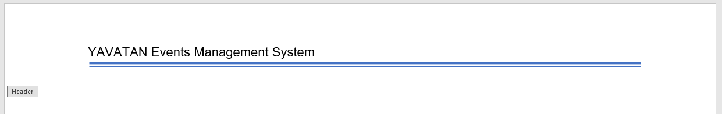

Add the “Agile Scrum System Documentation” text, left-aligned, Arial 11-pt, below the line in the footer section.

Sample: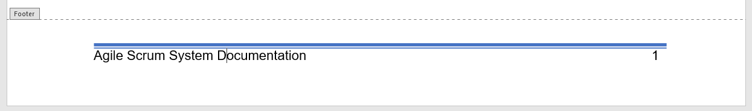

**Page Numbering**

The page counting for the preliminary section, *(Title page, Preface, Table of Contents, List of Figures and Tables)* is separate to the main content of the documentation. The page number is positioned in the bottom-part of the paper, aligned with the text in the footer.

The page for the title page will not be shown but included in the count.

For the preliminary section, the format of the page number will be roman numerals. For the main content, the format of the page number will be Arabic-numerals.

**Table Specifications**

**General Specifications**

1. Type above every table its number and title, and the number must be bold-faced.

2. Type the table number at the center and single-spaced from the last line of the immediately preceding paragraph.

3. Type the title of the table at the center, title case, and single–spaced from the table number, adding space after paragraph.

4. The numbering of tables shall be continuous.

5. Use the landscape page layout for large tables.

6. If the table is still too large to ﬁt a single page, reduce the Arial font to a minimum of 8 points.

7. If the table does not ﬁt the page even after the font-size reduction, continue the rest of its part to the next page, but the cut part shall bear the subtitle, ‘Continuation’ ﬂush with the left margin (e.g., Continuation of Table 14). The cut part/s shall also show the column headings and the legend (if any) like those in the ﬁrst part of the table.

8. Put two or more small tables on a single page if the page is big enough to accommodate them all.

9. The font for the title columns must always be in ALL-CAPS, center-aligned.

10. The spacing for the content of the table is 1.15-pt.

**For Product Backlogs**

A table for product backlog must contain the following: User Story No, User Stories (description), User Story Priorities, Revised Priority, Status; respectively.

The text alignment for User Story No, User Story Priorities, Revised Priority, Status, must be center-aligned, except for the User Stories (description), which is left aligned.

The content in the status part of the table is only marked as “DONE” or “PENDING” depending on the status of the backlog. These words are formatted in ALL-CAPS.

Sample:

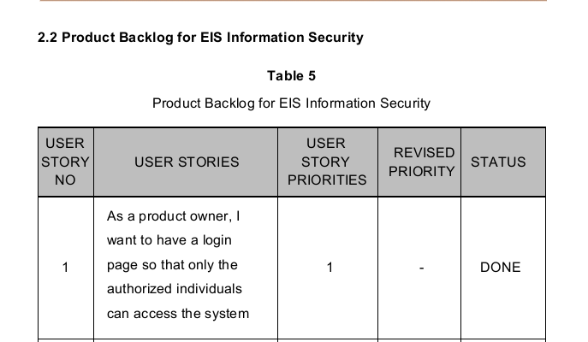

**For Sprint Backlogs**

A table for sprint backlog must contain the following: Number, Description, Tasks, Requirement Reference, PTS (Points) and Team Member; respectively.

The text alignment is center-aligned, except for the “TASK” column, which is left-aligned.

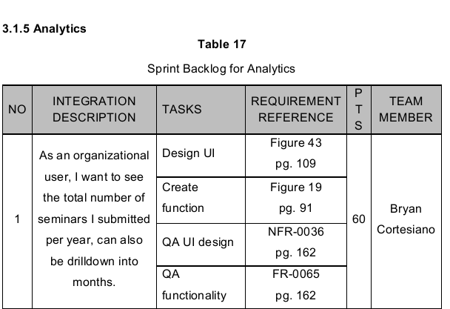Sample:

**Figure Specifications**

1. Type above every figure its number and right next to it is its title, and must be bold-faced.

2. Must be typed left-aligned, single-spaced from the top of the figure.

3. The numbering of figures shall be continuous.

Sample:

